Code 1:For Shearing Transformation on x-axis
import matplotlib.pyplot as plt
# Original triangle points
x = [1, 3, 2, 1]
y = [1, 1, 3, 1]
# Shear factors
shx = 0.75 # X-shear (slants shape sideways)
shy = 0.0 # Y-shear (no vertical slant)
# Apply shearing formulas
x_new = [x[i] + shx * y[i] for i in range(len(x))] # x' = x + shx * y
y_new = [y[i] + shy * x[i] for i in range(len(y))] # y' = y + shy * x
# Draw original and sheared triangle
plt.plot(x, y, 'bo-', label='Original Triangle')
plt.plot(x_new, y_new, 'ro-', label='Sheared Triangle')
plt.axis('equal')
plt.legend()
plt.title('Shearing Transformation (Triangle)')
plt.show()
Output:
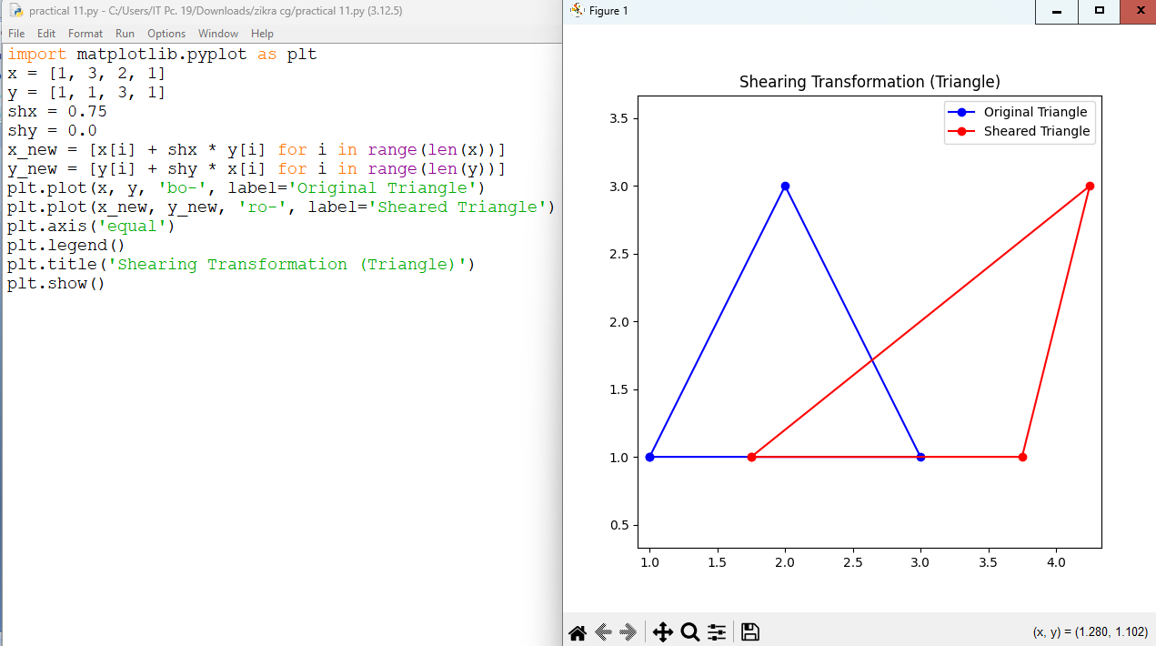
Code2:For Shearing Transformation on y-axis
import matplotlib.pyplot as plt
# Original triangle points
x = [1, 3, 2, 1]
y = [1, 1, 3, 1]
# Shear factors
shx = 0.0 # X-shear (slants shape sideways)
shy = 0.5 # Y-shear (no vertical slant)
# Apply shearing formulas
x_new = [x[i] + shx * y[i] for i in range(len(x))] # x' = x + shx * y
y_new = [y[i] + shy * x[i] for i in range(len(y))] # y' = y + shy * x
# Draw original and sheared triangle
plt.plot(x, y, 'bo-', label='Original Triangle')
plt.plot(x_new, y_new, 'ro-', label='Sheared Triangle')
plt.axis('equal')
plt.legend()
plt.title('Shearing Transformation (Triangle)')
plt.show()

output
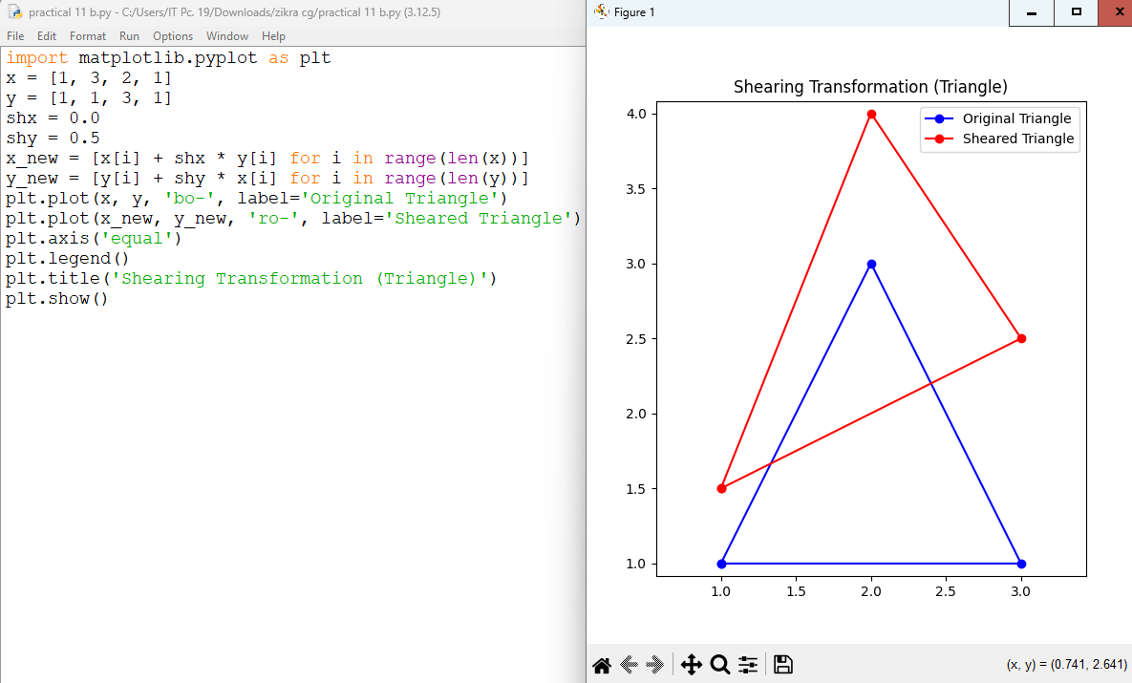

Code Explanation steps:

1 | Import matplotlib to draw shapes

2 | Define a simple square using x and y points

3 | Choose shear factors (shx, shy)

4 | Apply the shear formula to each point

5 | Draw both shapes — original (blue) and sheared (red)

6 | Show the result

